Gerund as a Verb Complement

✅ What Is a Gerund as a Verb Complement?
# Source: AI Source: Provided by: [Data Path: Persons Table -> ID Column: 1, Name_En Column: Motasem Essam] -> From: [ChatGPT] on [8/4/2025]
A gerund is the -ing form of a verb that functions as a noun. When used as a verb complement, the gerund follows the main verb and completes or receives its meaning.

🔸 Structure:
# Source: AI Source: Provided by: [Data Path: Persons Table -> ID Column: 1, Name_En Column: Motasem Essam] -> From: [ChatGPT] on [8/4/2025]
- Verb + gerund (verb ending in -ing)
- Common after verbs like: enjoy, avoid, consider, finish, suggest, deny, mind, keep, etc.

🔸 Examples:
# Source: AI Source: Provided by: [Data Path: Persons Table -> ID Column: 1, Name_En Column: Motasem Essam] -> From: [ChatGPT] on [8/4/2025]
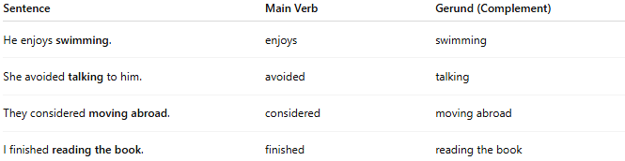
Sentence | Main Verb | Gerund (Complement)
He enjoys swimming. | enjoys | swimming
She avoided talking to him. | avoided | talking
They considered moving abroad. | considered | moving abroad
I finished reading the book. | finished | reading the book

🔸 Why It's a Verb Complement:
# Source: AI Source: Provided by: [Data Path: Persons Table -> ID Column: 1, Name_En Column: Motasem Essam] -> From: [ChatGPT] on [8/4/2025]
Because the gerund phrase is required to complete the verb's idea. The verb alone is incomplete without specifying the action.
🟢 Example:
- ✅ "She enjoys dancing." (complete)
- ❌ "She enjoys." (incomplete – enjoys what?)

